

**Artificial Intelligence and Data Science Department.**

OOPM / Odd Sem 2021-22 / Experiment 9.

YASH SARANG.

47 / D6AD.

EXPERIMENT - 9.

**____________________________________________________________**

**AIM:** To write a program to implement abstract class and abstract methods.

**____________________________________________________________**

**Program 1:**

import java.util.*;

abstract class Shape

{

abstract void area();

}

class triangle extends Shape

{

int h,b;

triangle(int h,int b)

{

this.h = h;

this.b = b;

}

void area()

{

System.out.println("Area of Triangle is :" + 0.5*b*h);

}

}

class circle extends Shape

{

int r; circle(int r)

{

this.r = r;

}

void area()

{

System.out.println("Area of Circle is :" + 3.142*r*r);

}

}

class square extends Shape

{

int l;

square( int l)

{

this.l = l;

}

void area()

{

System.out.println("Area of Square is :" + l*l);

}

}

class rectangle extends Shape

{

int l,b;

rectangle( int l, int b)

{

this.l = l;

this.b = b;

}

void area()

{

System.out.println("Area of rectangle is :" + l*b);

}

}

class abstracted

{

public static void main(String args[])

{

triangle T = new triangle(6,9);

circle C = new circle(20);

square S = new square(10);

rectangle R = new rectangle(5,15);

T.area();

C.area();

S.area();

R.area();

}

}

**The output of program 1:**

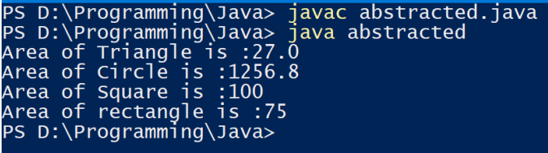

**____________________________________________________________**

**THEORY + CONCLUSION:**



